- Use Case Name: PlayGame
Participating Actor(s): Player
Description: The player would use this case to enter into the actual gameplay of the game.
Flow of Events:
- The player selects the option for playing the game from the main menu.
- The main menu disappears and another menu is displayed, asking the player to choose between playing on his/her own (i.e., single-player) or having the ability to see and interact with characters played by other people (i.e., multiplayer).
- If the player selects the multiplayer option, it would invoke InitiateMultiplayer, which would also give the player the ability to play alongside other players as a team by invoking JoinMultiplayer.
- Once the player’s choice between single-player and multiplayer is made, the menu disappears and GameControl requests data from the Database via the getSaveData(userID) method.
- After the Database is accessed, it searches for an account with an ID that matches userID.
- When the correct account is found, the data that has been saved for it is retrieved and returned to GameControl.
- GameControl, then, sends this data to PlayGame via the loadSaveData() method.
- PlayGame, then, updates GameControl’s display and receives input generated by the player via enterInput().
- While the game is played, the player’s progress is continually updated and saved to his/her user account in the Database via updateSaveData().
Entry Conditions: The player has invoked LaunchGame.
Exit Conditions: The player either resumes the gameplay from where he/she left off, or begins a new adventure. He/She can perform the gameplay functions (i.e., movement, speech, etc.).
Alternative Flow: I could not think of one.
Exceptions Flow:
- The player selects the option for playing the game from the main menu.
- However, the player loses his/her Internet connection and is unable to load, update, and save his/her data.
- A message is displayed, telling the player that he/she is no longer connected to the Internet and, therefore, is unable to play the game.
- The player closes the message and gets returned to the previous menu.

- Use Case Name: LaunchGame
Participating Actor(s): Player
Description: The player would use this case to activate the game.
Flow of Events:
- The player clicks on the launch icon.
- Game opens
- The player enters their username and password into text fields to login to their account
- Click enter button/hit enter key to submit.
- System executes checkInputData() to find the relevant user
- Relevant data is sent to the user
- Game goes to main menu via the mainMenu() method
Entry Conditions: The player has downloaded/installed the game.
Exit Conditions: The player can now perform the activities provided in the main menu.
Alternative Flow: I could not think of one.
Exceptions Flow:
- The player enters his/her username and password to login to his/her account.
- Something was typed wrong, so a message is displayed to let the player know what the issue is and in which textbox it occurred.
- The player is asked to check the spelling and either correct it or re-type the information before attempting to submit it again.
- Use Case Name: CloseGame
Participating Actor(s): Player
Description: The player would use this case to end/exit the game.
Flow of Events:
- There is a button on the screen during gameplay for leaving it and returning to the main menu.
- The player clicks on the button.
- The main menu also has an option for terminating the game entirely.
- The player selects this option.
- PlayGame is called via the startClose() method.
- The Database’s data for the player’s account is updated and saved via updateSaveData().
- PlayGame, then, calls GameControl via startClose().
- GameControl initiates the logout process by calling LaunchGame via the logout() method.
- Finally, LaunchGame confirms that the preceding steps have been executed successfully via confirmClose().
Entry Conditions: The player is done with the game.
Exit Conditions: The player’s place in the game is saved and the screen disappears when he/she closes it.
Alternative Flow: I could not think of one.
Exceptions Flow:
- There is a button on the screen during gameplay for leaving it and returning to the main menu.
- The player clicks on the button.
- The main menu also has an option for terminating the game entirely.
- The player selects this option.
- An error occurs while the Database’s data for the player’s account is being updated and saved via updateSaveData().
- A message tells the player what has happened and to try closing the game again.

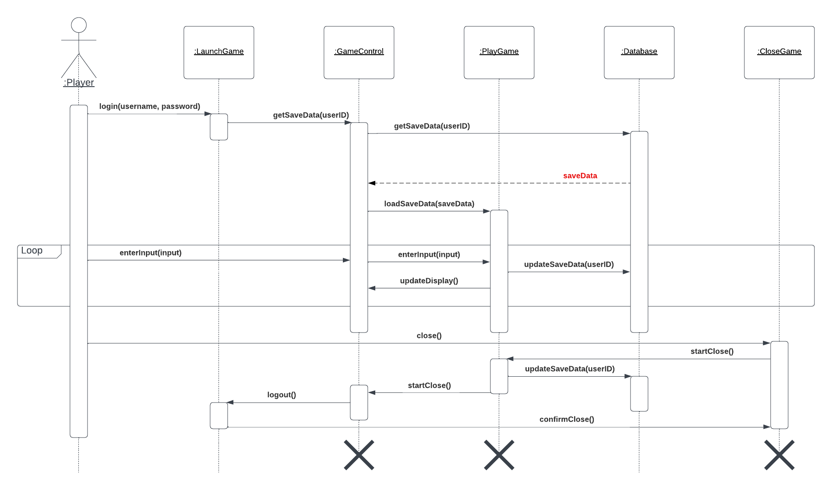
(Dynamic Model Above)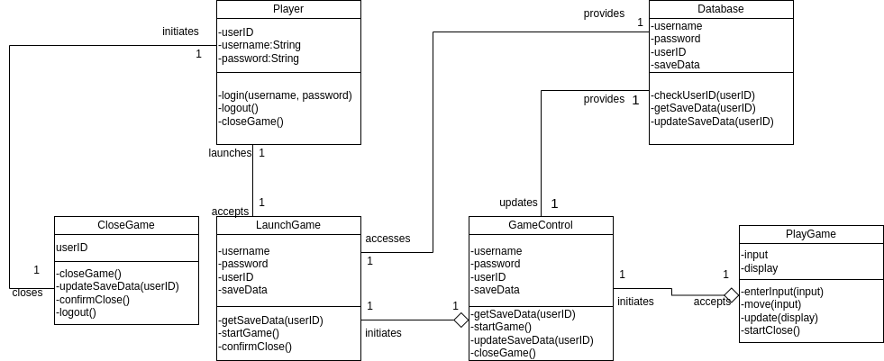
(Analysis Object Model Above)

